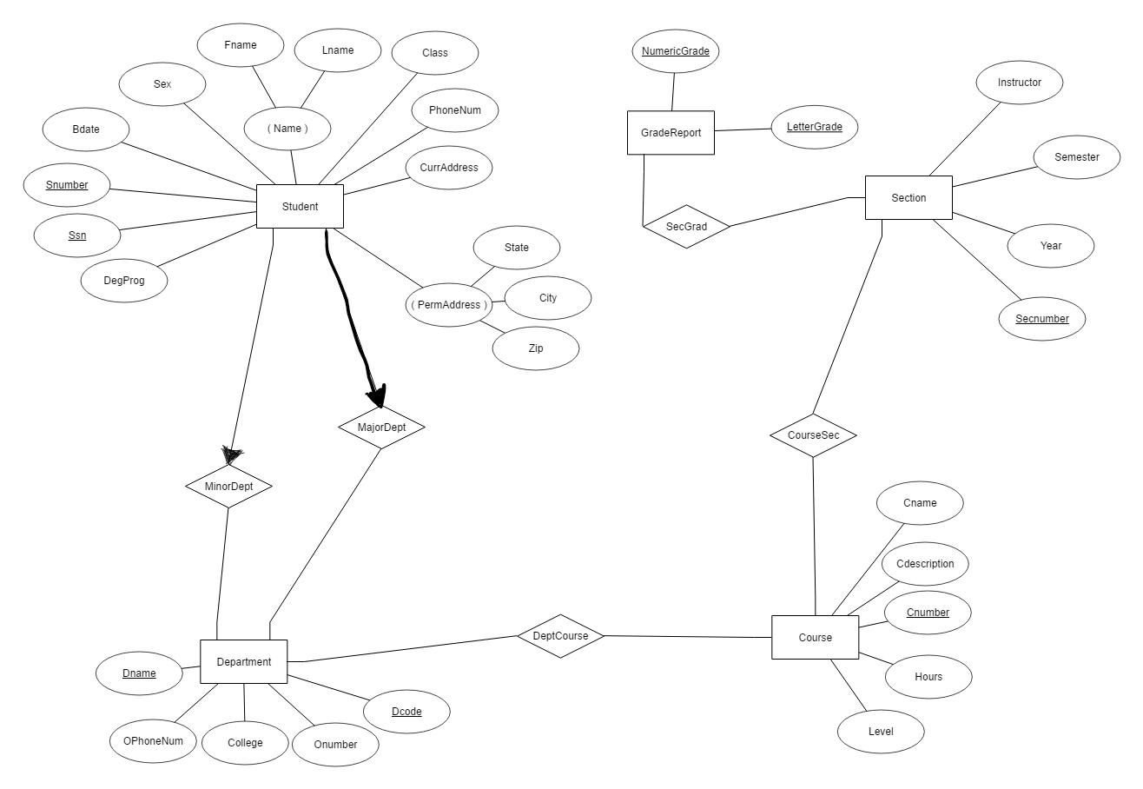**7.16**

**7.19**

Consider the following requirements for an AIRPORT database:

* The airport keeps track of the airport code, name, and the city and state where the airport is located. The airport code is unique for each airport.
* Each flight has a flight number, airline, days of the week it operates. The flight number is unique for each flight. Each flight has one or more flight legs.
* Each flight leg has a departure airport, departure time, arrival airport, and arrival time.
* Each leg instance contains information on each flight leg, such as, a date, times the flight departed and arrived, number of seats available, and the airplane assigned to the flight.
* A customer may make a reservation on a leg instance that uses the customer name, phone number, and the seat number on the airplane.
* Each airplane has an airplane ID, type, total number of seats. The airplane ID is unique for each airplane.
* Each airplane type has a company, type name, max number of seats, and whether that plan can land at the airport. The type name is unique for each airplane type.

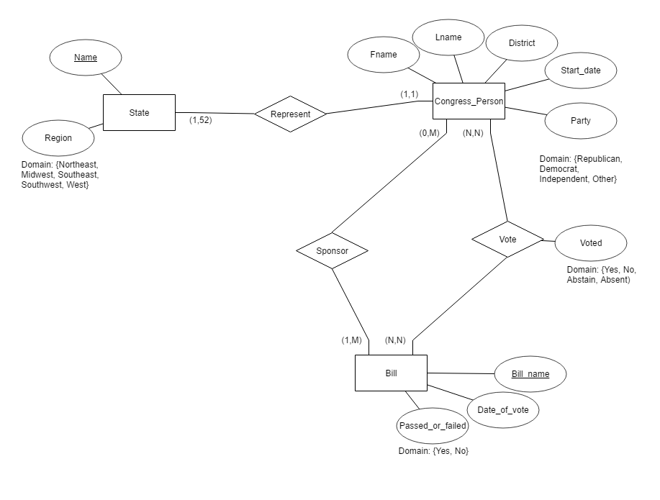**7.21**

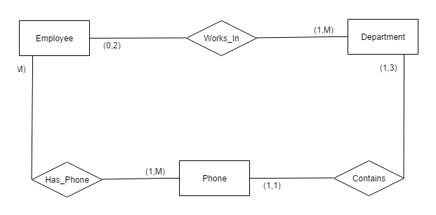**7.24**

**7.27**

1. STUDENT 1:N SOCIAL_SECURITY_CARD  
   A student can have multiple social security cards.
2. STUDENT M:1 TEACHER  
   Many students can be taught by a teacher; assume one class.
3. CLASSROOM M:N WALL  
   Many classrooms can have many walls.
4. COUNTRY 1:1 CURRENT_PRESIDENT  
   One country can only have one president; assume democracy.
5. COURSE M:N TEXTBOOK  
   Multiple courses can have multiple textbooks.
6. ITEM (that can be found in an order) N:M ORDER  
   Many items can be found in many orders.
7. STUDENT M:N CLASS  
   Many students can have many classes.
8. CLASS M:1 INSTRUCTOR  
   Many classes can have one instructor.
9. INSTRUCTOR 1:1 OFFICE  
   A instructor has one office.
10. EBAY_AUCTION_ITEM 1:M EBAY_BID

One item on EBAY can have many bids.

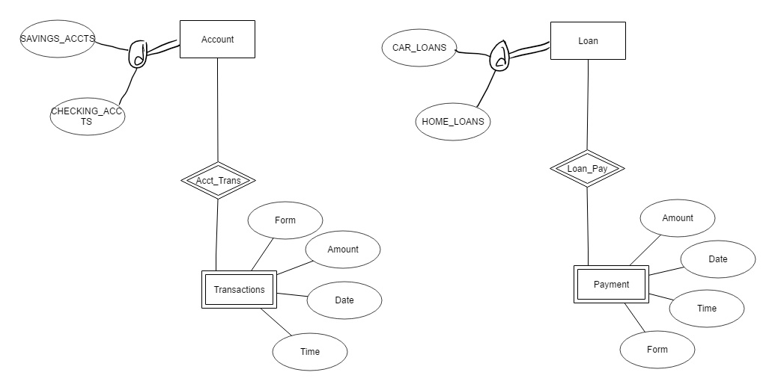**8.17**

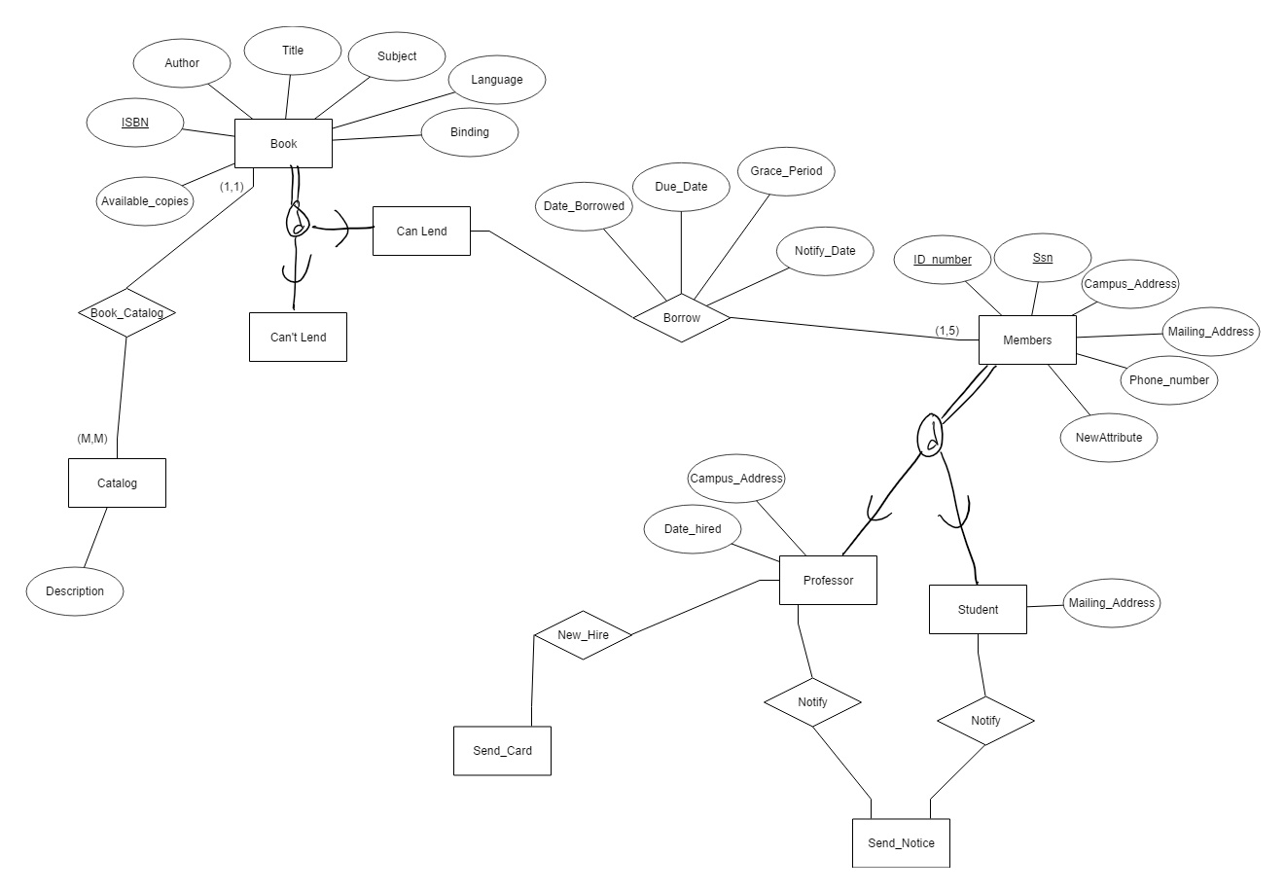**8.19**

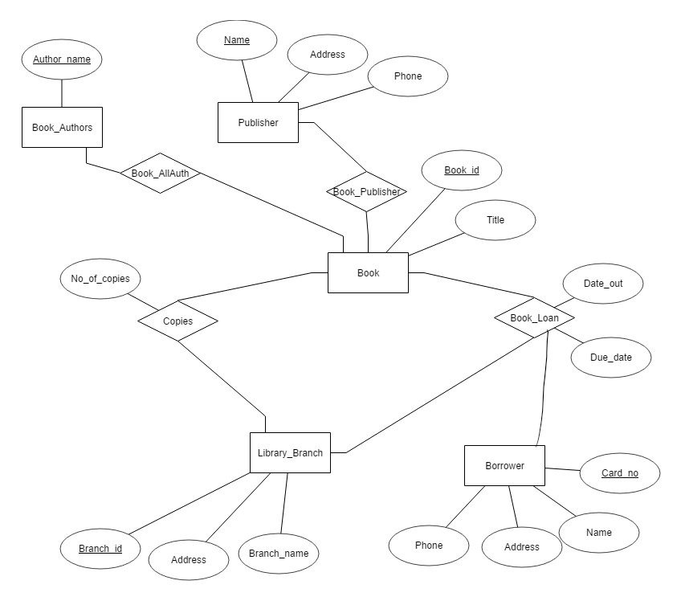**9.3**

**9.4**